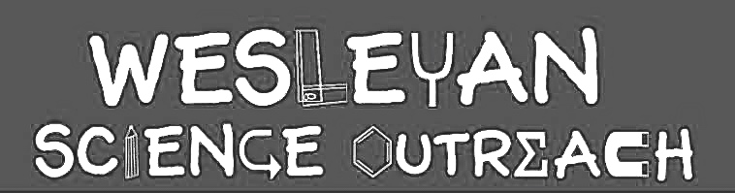

Alyssa Glanzer
1/27/15

Brain Teasers!

Our brain teasers lesson will center largely around optical illusions, which use color, light, and patterns to create images that can be misleading to our brains. Sometimes the information collected by our eyes is processed in a way that makes us see an image differently than it actually is. The context you see an image in can affect how your brain sees it, and this may be different than what it truly is!

Material List

- Printouts of optical illusions
- 10ish rulers
- 2-3 staplers
- Index cards (1 per kid- 100?)
- Markers!
- Crayons
- Straws (1 per kid)
- Scissors (1 per kid if possible)

Activities

1. Introduction/ Images of cool optical illusions
Duration: 10 minutes

Ask the kids if they know what an optical illusion is or if they’ve ever seen one before. If they have, ask them to describe what was so cool about the optical illusion they saw! Next, show them the printouts of the optical illusions and have the kids explain what they see! Go through each image and ask them what they see. In the first set of pictures there are two different images they could be seeing. Take a poll- for example- how many of them first saw the man planning the tuba, and how many first saw the woman’s face?
These pictures can be perceived as 2 different things! Ask them why they think they saw it one way first and try to get them to see the other way. Explain that once you see the second image, you can’t unsee it!
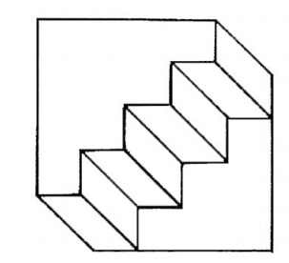
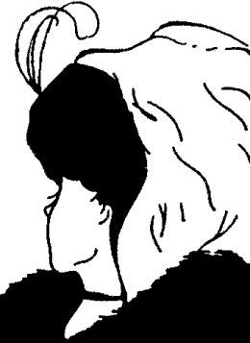
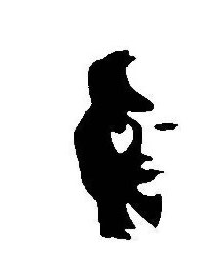
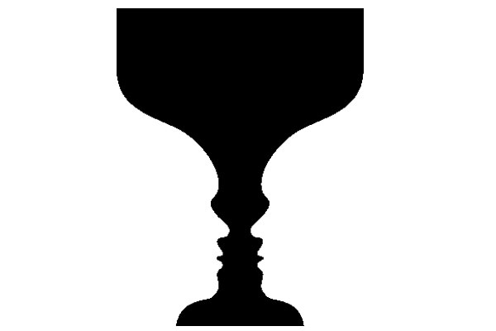


Two heads or goblet?
Man playing tuba or woman’s face?
Old or young woman?
Duck or bunny? Stairs on the floor or the ceiling?
Random shapes or the word lift?

Show them these images related to how we perceive size. Ask the kids if they remember the arrow activity they did last year and what was cool about the lines (they are the same size). Ask them which plate they think has more food- they will probably think the smallest one, but they actually have the same amount of food! For the tables, also discuss how they are actually the same size. Have them use rulers if they are doubtful. Objects can appear larger or smaller when placed next to objects of different sizes. The context we see things in affects how we perceive them. With the tables, their different positioning relative to us is why we think they are different sizes.

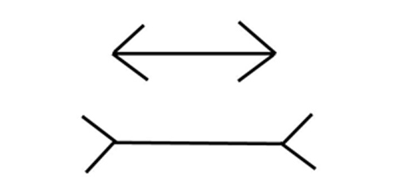
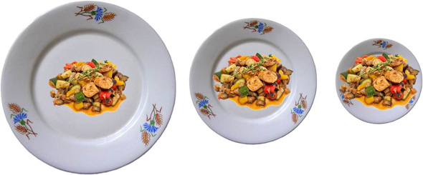
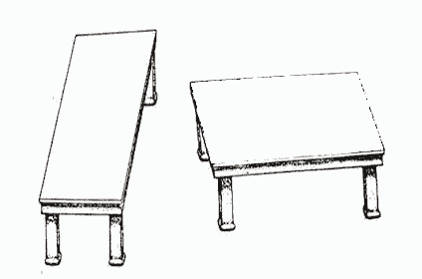

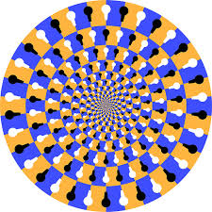
Sometimes your brain sees images as moving even though they aren’t! There is so much going on in these images that your brain can’t process it all- and it relies on shortcuts to make sense of the image, which is why in these it looks like the images are moving!
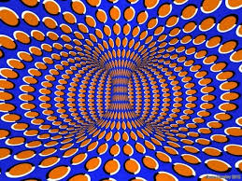
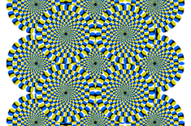
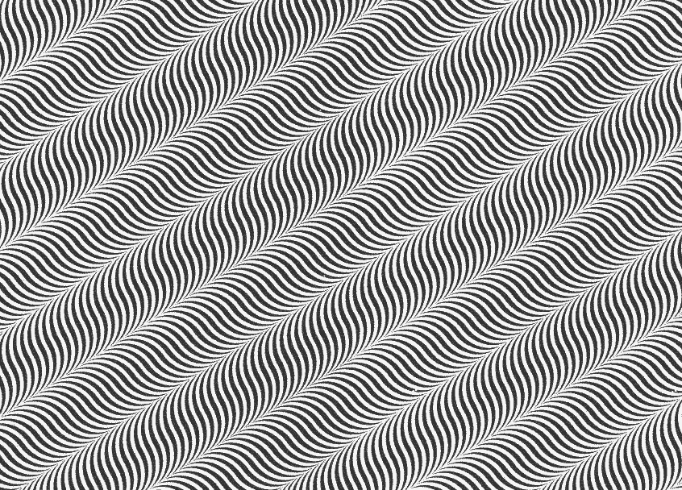

Sometimes your brain percieves colors differently based on what other colors or shapes are surrounding the object. In these examples, you see two different colors when they are actually the same! Have kids cover up the other parts of the image and see that the two colors are the same!

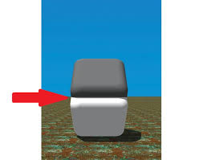


Sometimes our brain even thinks its seeing curved lines, when the lines are actually parallel and straight! Check out these and have them use a ruler if they don’t believe the lines are parallel!
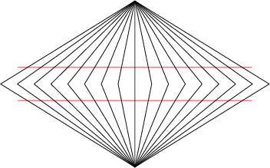
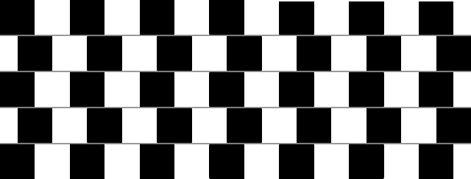
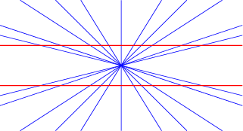

Here’s another cool one: You perceive grey blobs in the intersection of the squares, but they are not actually there:
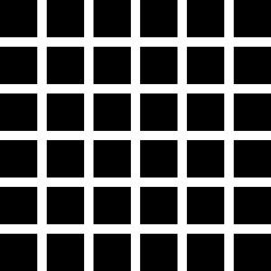

For this one, have them stare at the dot inside the flag for 30 seconds. Then have them look away at a white surface (maybe the wall, ceiling)- they should see a red, white and blue American flag!
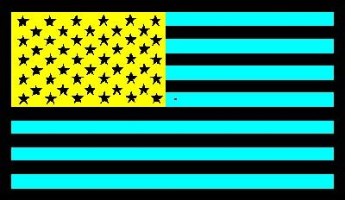

2. Stroop Test
Duration: 10 minutes

Split students into several groups, with a volunteer/club leader each having a group. The volunteer will have several pieces of paper with names of colors on them (ex- red, blue, green, orange, blue, purple, yellow, etc). However, the trick is, the text of the word might be in a different color! The task is to say the color of the text of the word, and not just reading the word. Some of the papers will have all matched colors and words, some will have all mismatched, and some will have mixed. Have kids make a hypothesis about which one they will be best at and then time them as they do the test! Discuss which one was harder and why they made more mistakes when the color doesn’t match the word.
Explain that this happens because when they try to say the color of the text their brain can’t help but read the word anyway. When the two pieces of information conflict, your brain is confused and it takes longer to figure out what the correct answer is.

3. Size Optical Illusions
Duration: 10-15 minutes

Tell the kids that we are going to make our own optical illusion about things looking like they are different sizes, similar to what they did with their arrows last year! We will use two images as examples: Students can do one or both depending on how fast they finish:
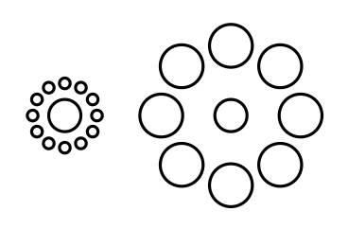
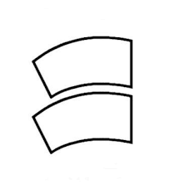

Printouts of these optical illusions for each student will be in the bin. First show the students the images, and have them hypothesize which one is bigger- is the shape on bottom or top bigger? What about the two middle circles? Tell them that they are going to do an experiment to find out. Instruct them to color in the images as they please (we will have markers and crayons in the box!). When they are done decorating, have them cut their images and place the two shapes or the two circles on top of each other. They will see that the shapes are actually the same size! Explain how just like we saw with the plates example, the context you see an image in affects how your brain perceives it!

4. Thaumatrope
Duration: 10-15 minutes

Students will be making their own optical illusions! To make a thaumatrope, a type of optical illusion, we will need an index card, a straw, tape, and some markers or crayons! To make- have students fold their index card in half. Then draw two pictures (on the blank side of the index cards- one on each half) that can combine to make one picture. Have them imagine two pictures that would blend well together. Some possible examples: fish and fish-tank, dog and doghouse, bird and cage, raindrops and umbrella- things that another thing can go inside of would work well for this. Have them draw one image (for example, the fish-tank) on one half of the index card, and the other (the fish) on the other half so that when the index card is folded they are on opposite sides. Once they are done coloring, fold the index card and tape the straw to the middle of one of the sides. Then tape the non-folded sides together. Have them rotate it back and forth quickly- the two images will start to appear together!
Explain that this happens because your eyes only see the fish or the bowl (or whatever the two images are- use the model as an example), but your brain can’t keep up! So when you spin quickly your brain sees it as a fish in a bowl! Thaumatropes show the persistence of vision effect. This means that images remain on the retina cones of our eyes for not even a second after light first hits them- but since the image remains even just for a split second and we are spinning our thaumatrope so fast, it appears that the two images are one. Explain that in reality we know that they are two different images, but our perception (how we see it) is different!
After students make one, have them try each other’s thaumatropes and even experiment with other ideas! What happens if you color in the water of the fish tank darker? If there is extra time have them make another design!

Conclusion

Sometimes how our brain interprets an image and what the image actually is do not match up! This is called an optical illusion. Sometimes the context of the image affects how our brain processes it, like we saw with our arrows and even with the stroop test, when we learned that it was harder to say the color when the color didn’t match the word! Our brain’s expectations guide its understanding of the world around us, and sometimes it makes shortcuts that may trick us! We can use how we perceive optical illusions to better understand how the brain works and interprets images.

Instructor Comments
- Make sure to have the students discuss the images in the groupings above- they were purposely grouped together because they are similar optical illusions, and will be easier to discuss that way. If the papers aren’t in order, use the mini-images on the LP to guide you.
- For the introduction, there are a lot of images and you could easily spend the whole 45 minutes talking about them- spend more time on the ones the students are most interested in, and feel free to skip some depending on what you think your students will like the best. At the end of the lesson, if students finish the thaumatrope early allow them to look more closely at the images- just make sure they are put back in the box at the end.

